23.72: (a) Points 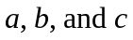 are all at the same potential because 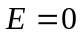 inside the spherical shell of charge on the outer surface. So 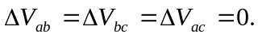
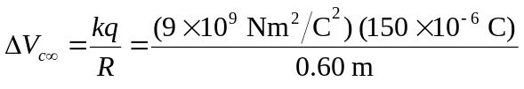
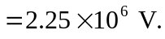
(b) They are all at the same potential
(c) Only 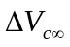 would change; it would be 